- Go to utdallas.edu and select the Galaxy link under the Resources drop down box in the top right hand corner of the UT Dallas home.

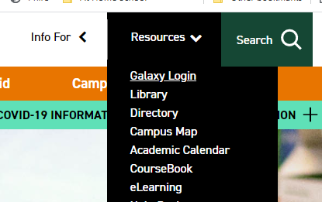
- Select the Orion link in the next Galaxy page to login using your netid and password.
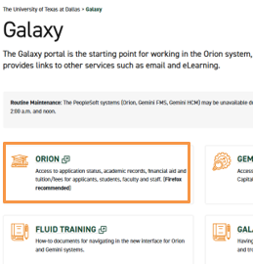
- Login to galaxy with your NetId and password.
  - If you don’t know your NetID and password or aren’t able to login, please contact the Help Desk using the link on the sign in page.
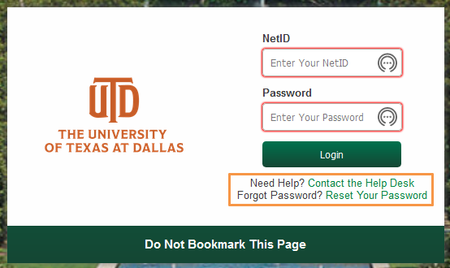
- Within your UTD Student Center, select the Graduation tile. 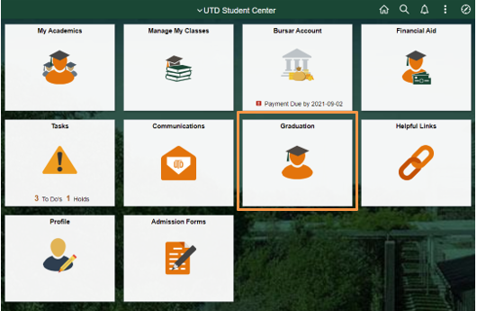

- Select ‘Graduation Verification Letter’ on the left navigation.

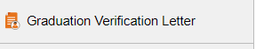

- Use the magnifying glasses to select the appropriate Degree, Academic Plan, and Confer Date.
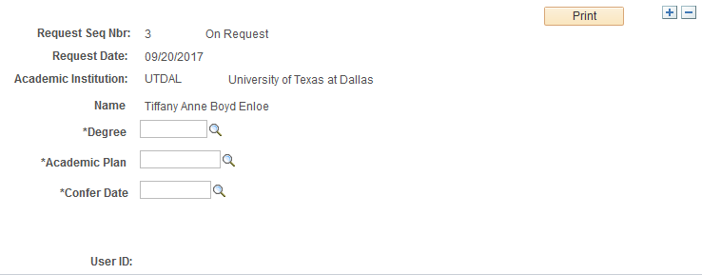
- Click “Print” to print your Graduation Verification Letter.

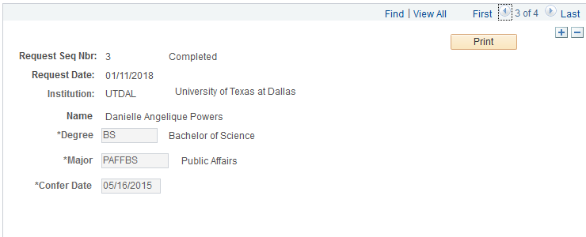
- If done correctly, the printed letter should look similar to the image below.

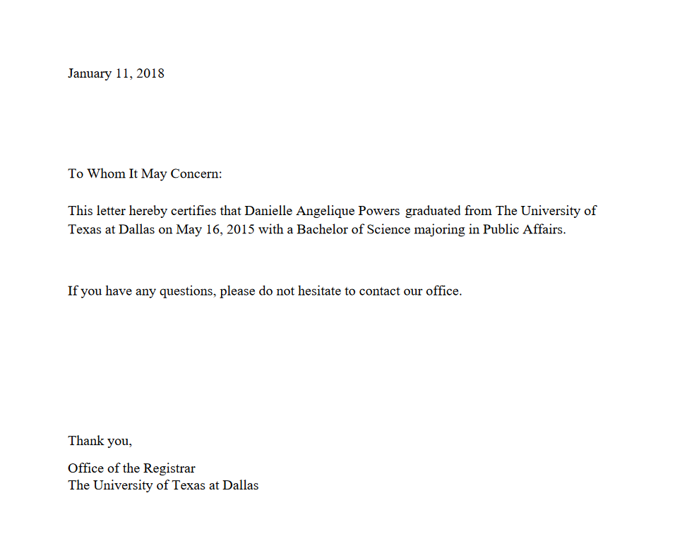

Note- The following steps are only for students earned a degree with a Double Major.
Double Major Students
- If you earned a double major, you will input your first major into the “Major” field. Once you have entered the first major, the “Major Two” box will then appear for you to select your second major.

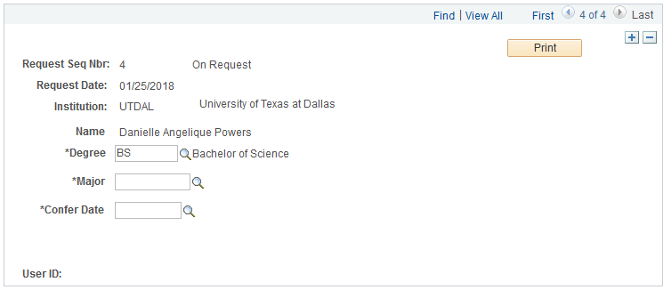
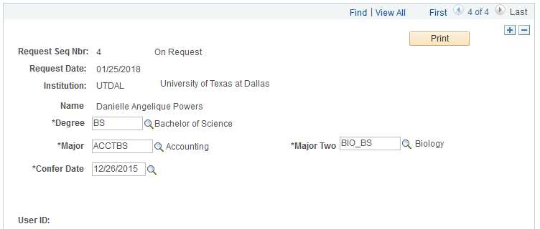

- The following image is how the letter should appear for students who earned a double major degree
